Name: Jarod Peachey
Date: 3-16-2020
16.06 Picture Lab Worksheet
Activity 8 Exercise Results

- Paste the image that is the result of calling the second copy method that adds parameters to allow you to copy just part of the fromPic.

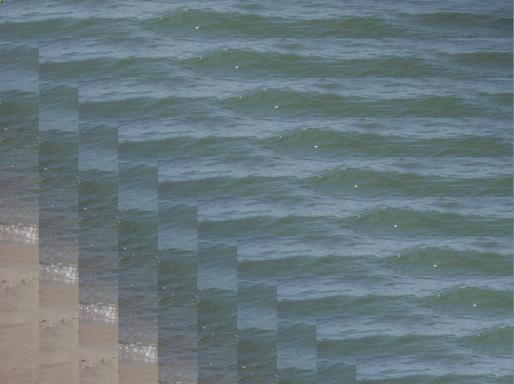
- Paste the image that is the result of calling the myCollage method.

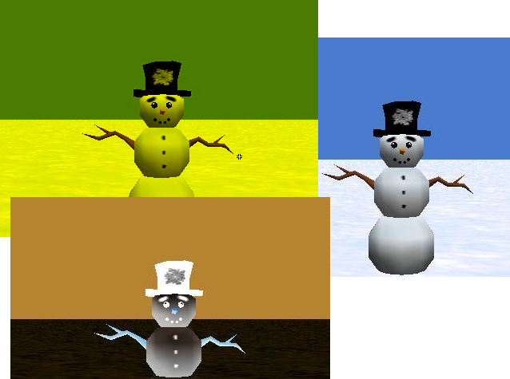

Activity 9 Exercise Results
- Paste the image that is the result of calling the edgeDetection2 method.

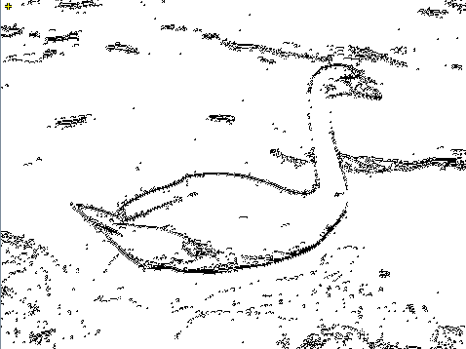

- Think about and propose another algorithm for edge detection.
It might be possible to detect edges by getting all the pixel colors and finding the dominant color. Then, detect any pixel that’s within 2 pixels of the place where the dominant color stops, and make that the black color.
However, this would not be as effective as the current edge detection algorithm.

